VISVESVARAYA TECHNOLOGICAL UNIVERSITY
"Jnana Sangama", Belagavi: 590 018


A Database Management Systems Mini Project report on

Computer-Laboratory Management System
Submitted in partial fulfillment of the requirement for the award of Degree of
BACHELOR OF ENGINEERING
IN
COMPUTER SCIENCE AND ENGINEERING
By
NAME: PRABHAT KUMAR AND PRAVEEN KUMAR SINGH
USN: 1AY19CS071 AND 1AY19CS078

Under the guidance of
Prof. Swathi U


DEPARTMENT OF COMPUTER SCIENCE & ENGINEERING
ACHARYA INSTITUTE OF TECHNOLOGY
(Affiliated to Visvesvaraya Technological University, Belagavi)
2021-2022

ACHARYA INSTITUTE OF TECHNOLOGY
(Affiliated to Visvesvaraya Technological University, Belagavi)
Soladevanahalli, Bangalore – 560090

DEPARTMENT OF COMPUTER SCIENCE AND ENGINEERING


Certificate

Certified that the Database Management Systems mini project entitled “Computer-Laboratory Management System” is a bonafide work carried out by PRABHAT KUMAR (1AY19CS071) & PRAVEEN KUMAR SINGH (1AY19CS078) of 5th semester in partial fulfillment for the award of degree of Bachelor of Engineering in Computer Science & Engineering of the Visvesvaraya Technological University, Belagavi, during the year 2021-2022. It is certified that all corrections/ suggestions indicated for internal assessments have been incorporated in the Report deposited in the departmental library. The Mini Project report has been approved as it satisfies the academic requirements in respect of Mini Project work prescribed for the Bachelor of Engineering Degree.

Signature of Guides Signature of H.O.D

Prof. Swathi U Dr. Ajith Padyana

Name of the examiners Signature with date

ABSTRACT

The main aim of the “Computer-Laboratory Management System” mini project is designed to managing various type of data and content related to the “Computer laboratory” in school, colleges and other institutes. It has the real world object as an entity in Database like teacher, student, systems, batch etc. It will help admin to maintain, access, update and retrieval of useful information and contents from database very easily and at any time This is very useful for handling the Computer labs in the various type of institution. It also helpful in designing the batch by providing a particular working system to every student.

ACKNOWLEDGEMENT

The satisfaction that accompanies the successful completion of this mini-project would be incomplete without the mention of the people who made it possible through constant guidance and encouragement.
We would take this opportunity to express our heart-felt gratitude to Sri. B. Premnath Reddy, Chairman, Acharya Institutes and Dr. Prakash M R, Principal, Acharya Institute of Technology for providing the necessary infrastructure to complete this mini-project.
We wish to express our deepest gratitude and thanks to Prof. Ajith Padyana, Head of the Department, Computer Science and Engineering.
We wish to express sincere thanks to my guide Prof. Swathy U, Assistant Professor, Department of Computer Science and Engineering for helping us throughout and guiding us from time to time.
A warm thanks to all the faculty of Department of Computer Science and Engineering, who have helped us with their views and encouraging ideas.

 | TABLE OF CONTENTS
Abstract |  | (i)
Acknowledgement |  | (ii)
Table of contents |  | (iii)
List of figures |  | (v)

Introduction………………………………………………… .…………1
  - Introduction to database management system 1
  - History of DBMS 1
  - Applications of DBMS 2
  - Overview of the project 3
  - Theory and Concepts 3
  - Applications of DBMS 2
  - SQLAlchemy 5
  - XAMPP server 5

- System Requirements Specification 6
  - Functional Requirements 6
  - Non-Functional Requirements 6
    - Hardware Requirements 6
    - Software Requirements 7
- System Design 8
  - Input Design 8
  - Database Design 8
  - Relational schema 8

  - ER Diagram 10
- System Implementation 12
  - Implementation 12
  - Connection of database 12
  - Creation of table 13
  - lab data base 15
  - Inserted values 16
  - Trigger inserted 18
- Snapshots 19
- Conclusion 25
- Bibliography 26

LIST OF FIGURES

Figure 3.1: Relational schema………………………………………………………09
Figure 3.2: Relational schema pictorial……………………………………………..10
Figure 3.3: ER-Diagram…………………………………………………………….11
Figure 4.1: Connection of Data Base……………………………………………….12
Figure 4.2: Teacher table……………………………………………………………13
Figure 4.4: Teacher table structure………………………………………………….13
Figure 4.3: Batch table…………………………………………………………..…..13
Figure 4.4: Batch table structure……………………………………………………13
Figure 4.5: System table……………………………………………………………14
Figure 4.6: System table structure………………………………………………….14
Figure 4.7: Student table……………………………………………………………14
Figure 4.8: Student table structure………………………………………………….14
Figure 4.9: Experiment table……………………………………………………….15
Figure 4.10: Experiment table structure……………………………………………15
Figure 4.11: Lab Data Base………………………………………………………...15
Figure 4.12: Teacher table data…………………………………………………….16
Figure 4.13: Batch table data……………………………………………………….16
Figure 4.14: System table data………………………………………………….….17
Figure 4.15: Trigger………………………………………………….…………….18
Figure 5.1: Home page #1………………………………………………………….19
Figure 5.2: Home page #2………………………………………………………….19
Figure 5.3: Login page……………………………………………………………..20
Figure 5.4: Admin home page………………………………………………….…..20
Figure 5.5: Add system page……………………………………………..………...21
Figure 5.6: Add Teacher page…………………………………………..………….21
Figure 5.7: Add Batch page…………………………………………………….…..22
Figure 5.8: Add Student page……………………………………………….…...…22
Figure 5.9: Add Experiment page………………………………………………..…23
Figure 5.10: Update and delete page………………………………………….……23
Figure 5.11: data table page……………………………………………….….……24

CHAPTER 1
INTRODUCTION

INTRODUCTION TO DATABASE MANAGEMENT SYSTEM
DBMS stands for Database Management System. We can break it like this DBMS = Database + Management System. Database is a collection of data and Management System is a set of programs to store and retrieve those data. Basically, DBMS is a software tool to organize (create, retrieve, update and manage) data in a database.
The main aim of a DBMS is to supply a way to store up and retrieve database information that is both convenient and efficient. By data, we mean known facts that can be recorded and that have embedded meaning. Normally people use software such as DBASE IV or V, Microsoft ACCESS, or EXCEL to store data in the form of database. A datum is a unit of data. Meaningful data combined to form information. Hence, information is interpreted data – data provided with semantics. MS. ACCESS is one of the most common examples of database management software.
Database systems are meant to handle large collection of information. Management of data involves both defining structures for storage of information and providing mechanisms that can do the manipulation of those stored information. Moreover, the database system must ensure the safety of the information stored, despite system crashes or attempts at unauthorized access.
  - History of DBMS

In 1959, the TX-2 computer was developed at MIT's Lincoln Laboratory. The TX- 2 integrated a number of new man-machine interfaces. A light pen could be used to draw sketches on the computer using Ivan Sutherland's revolutionary Sketchpad software. Using a light pen, Sketchpad allowed one to draw simple shapes on the computer screen, save them and even recall them later. The light pen itself had a small photoelectric cell in its tip. This cell emitted an electronic pulse whenever it was placed in front of a computer screen and the screen's electron gun fired directly at it. By simply timing the electronic pulse with the current location of the electron gun, it was easy top in point exactly where the pen was on the screen at any given moment.

Once that was determined, the computer could then draw a cursor at that location. Also, in 1961 another student at MIT, Steve Russell, created the first video game, E. E. Zajac, a scientist at Bell Telephone Laboratory (BTL), created a film called "Simulation of a two-gravity attitude control system" in 1963. During 1970s, the first major advance in 3D computer graphics was created at UU by these early pioneers, the hidden-surface algorithm. In order to draw a representation of a 3D object on the screen, the computer must determine which surfaces are "behind" the object from the viewer's perspective, and thus should be "hidden" when the computer creates (or renders) the image. In the 1980s, artists and graphic designers began to see the personal computer, particularly the Commodore Amiga and Macintosh, as a serious design tool, one that could save time and draw more accurately than other methods.

In the late 1980s, SGI computers were used to create some of the first fully computer-generated short films at Pixar. The Macintosh remains a highly popular tool for computer graphics among graphic design studios and businesses. Modern computers, dating from the 1980s often use graphical user interfaces (GUI) to present data and information with symbols, icons and pictures, rather than text. Graphics are one of the five key elements of multimedia technology. 3D graphics became more popular in the 1990s in gaming, multimedia and animation. In 1996, Quake, one of the first fully 3D games, was released. In 1995, Toy Story, the first full-length computer-generated animation film, was released in cinemas worldwide. Since then, computer graphics have only become more detailed and realistic, due to more powerful graphics hardware and 3D modeling software.
  - APPLICATIONS OF DBMS
Applications where we use Database Management Systems are:

Telecom: There is a database to keeps track of the information regarding calls made, network usage, customer details etc. Without the database systems it is hard to maintain that huge amount of data that keeps updating every millisecond.
Industry: Where it is a manufacturing unit, warehouse or distribution Centre, each one needs a database to keep the records of ins and outs. For example, distribution Centre should keep a track of the product units that supplied into the Centre as well as the products that got delivered out from the distribution Centre on each day; this is where DBMS comes into picture.

Banking System: For storing customer info, tracking day to day credit and debit transactions, generating bank statements etc. All this work has been done with the help of Database management systems.
Education sector: Database systems are frequently used in schools and colleges to store and retrieve the data regarding student details, staff details, course details, exam details, payroll data, attendance details, fees detail etc. There is a hell lot amount of inter-related data that needs to be stored and retrieved in an efficient manner.
Online shopping: You must be aware of the online shopping websites such as Amazon, Flipkart etc. These sites store the product information, your addresses and preferences, credit details and provide you the relevant list of products based on your query. All this involves a Database management system.
  - Overview of the project

Today the world's most forward-looking institutes are trying to Shift every things digitalize in their field, so that the preserving the records in register in older manner to be reduced and easy to find the required data. Every institution nowadays is trying to computerize its all activities to insure better data management of student, institution assets and tracking student growth in academics. The aim is to automate its existing manual system by the help of computerized equipment and full-fledged computer software, fulfilling their requirements, so that their valuable data/information can be stored for a longer period with easy accessing and manipulation of the same by authorized personal.
The project, “Computer-Laboratory Management System” is also a step towards offering more or less the similar features in computer laboratory of institution.
Computer-Laboratory Management System enables the Institution to handle data in more systematic and efficient manner, hence improving the utilization of Laboratory in more sufficient way.

  - Theory and Concepts

Inheritance: In object-oriented programming, inheritance is when an object or class is based on another object or class, using the same implementation (inheriting from an
object or class) or specifying a new implementation to maintain the same behavior

(realizing an interface). Such inherited class is called a subclass of its parent class or super class.
Encapsulation: In object-oriented programming, encapsulation is a mechanism of binding the data, and the functions together in a class and use them by creating an object of that class.
Data Abstraction: Data abstraction refers to, providing only essential information to the outside world and hiding their background details, i.e., to represent the needed information in program without presenting the implementation details. Data abstraction is a programming (and design) technique that relies on the separation of interface and implementation.

  - Advantages of DBMS
DBMS manages data and has many advantages.
● Data Independence: Application programs should be as free or independent as possible from details of data representation and storage. DBMS can supply an abstract view of the data for insulating application code from such facts.
● Efficient data access: DBMS utilizes a mixture of sophisticated concepts and techniques for storing and retrieving data competently and this feature becomes important in cases where the data is stored on external storage devices.
● Data integrity and security: If data is accessed through the DBMS, the DBMS can enforce integrity constraints on the data.
● Data administration: When several users share the data, integrating the administration of data can offer major improvements. Experienced professionals understand the nature of the data being managed and can be responsible for organizing the data representation to reduce redundancy and make the data to retrieve efficiently.
● Providing backup and recovery: A DBMS must provide facilities for recovering from hardware or software failures. The backup and recovery subsystem of the DBMS is responsible for recovery.

● Permitting influencing and actions using rules: Some database systems provide capabilities for defining deduction rules for influencing new information from the stored database facts.

  - SQLAlchemy
SQLAlchemy is an open-source SQL toolkit and object-relational mapper (ORM) for the Python programming language released under the MIT License.
SQLAlchemy was first released in February 2006 and has quickly become one of the most widely used object-relational mapping tools in the Python community, alongside Django's ORM.
SQLAlchemy 's philosophy is that relational databases behave less like object collections as the scale gets larger and performance starts being a concern, while object collections behave less like tables and rows as more abstraction is designed into them. For this reason it has adopted the data mapper pattern rather than the active record pattern used by a number of other object-relational mappers. However, optional plugins allow users to develop using declarative syntax.

  - XAMPP server
XAMPP is a free and open-source cross-platform web server solution stack package developed by Apache Friends, consisting mainly of the Apache HTTP Server, Maria DB database, and interpreters for scripts written in the PHP and Perl programming languages. Since most actual web server deployments use the same components as XAMPP makes transitioning from a local test server to a live server possible. It is a simple, lightweight Apache distribution that makes it extremely easy for developers to create a local web server for testing and deployment purposes. Since most actual web server deployments use the same components as XAMPP, it makes transitioning from a local test server to a live server is extremely easy as well. Though it is a heavy app for most of the operating systems even when owing to its less size it takes a load on the processor speed.

CHAPTER 2

System Requirements Specification

  - Functional Requirements

The specific functional requirements of the Computer-Laboratory Management System are stated as follows:
Admin:
- Can Login
- Can CREATE
- Can Delete
- Can Update
- Can Add

  - Non-Functional Requirements

2.2.1 Hardware Requirement

The section of hardware configuration is an important task related to the software development insufficient random-access memory may affect adversely on the speed and efficiency of the entire system. The process should be powerful to handle the entire operations. The hard disk should have sufficient capacity to store the file and application.
- Processor :Intel PentiumT4200/ Intel Core Duo 2.0 GHz / more RAM
- Memory : Minimum 1GB RAM capacity
- Hard disk : Minimum 40 GB ROM
- GPU : Intel HD Graphics

2.2.2 Software Requirement

A major element in building a system is the section of compatible software since the software in the market is experiencing in geometric progression. Selected software should be acceptable by the firm and one user as well as it should be feasible for the system.
This document gives a detailed description of the software requirement specification. The study of requirement specification is focused specially on the functioning of the
system. It allows the developer or analyst to understand the system, function to be carried out the performance level to be obtained and corresponding interfaces to be established.

- Tools used : Visual Studio Code, My SQL v8.0.26, XAMPP
- Programming languages : PYTHON v.3.9.x
- Front end design : HTML5, CSS3, Flask
- Server : XAMPP server
- Database :MySQL or SQLAlchemy

CHAPTER 3
SYSTEM DESIGN
  - Input Design
The Dashboard provides a menu of different functionalities for both user and admin.
  - Database Design
The data in the system has to be stored and retrieved from the database. Designing the database is part of system design. Data elements and data structures to be stored have been identified at the analysis stage. They are structured and put together to design the data storage and retrieval system. A database is a collection of interrelated data stored with minimum redundancy to serve many users quickly and efficiently. The general objective is to make database access easy, quick, inexpensive and flexible for the user. Relationships are established between the data items and unnecessary data items are removed. Normalization is done to get an internal consistency of data and to have minimum redundancy and maximum stability. This ensures minimizing data storage required, minimizing chances of data inconsistencies and optimizing for updates. The MySQL database has been chosen for developing the relevant databases.
  - Relational Schema
The term "schema" refers to the organization of data as a blueprint of how the database is constructed (divided into database tables in the case of relational databases). The formal definition of a database schema is a set of formulas (sentences) called integrity constraints imposed on a database. A relational schema shows references among fields in the database. When a primary key is referenced in another table in the database, it is called a foreign key. This is denoted by an arrow with the head pointing at the referenced key attribute. A schema diagram helps organize values in the database. It also gives an idea of what order the tables should be created in. The following diagram shows the schema diagram for the database.
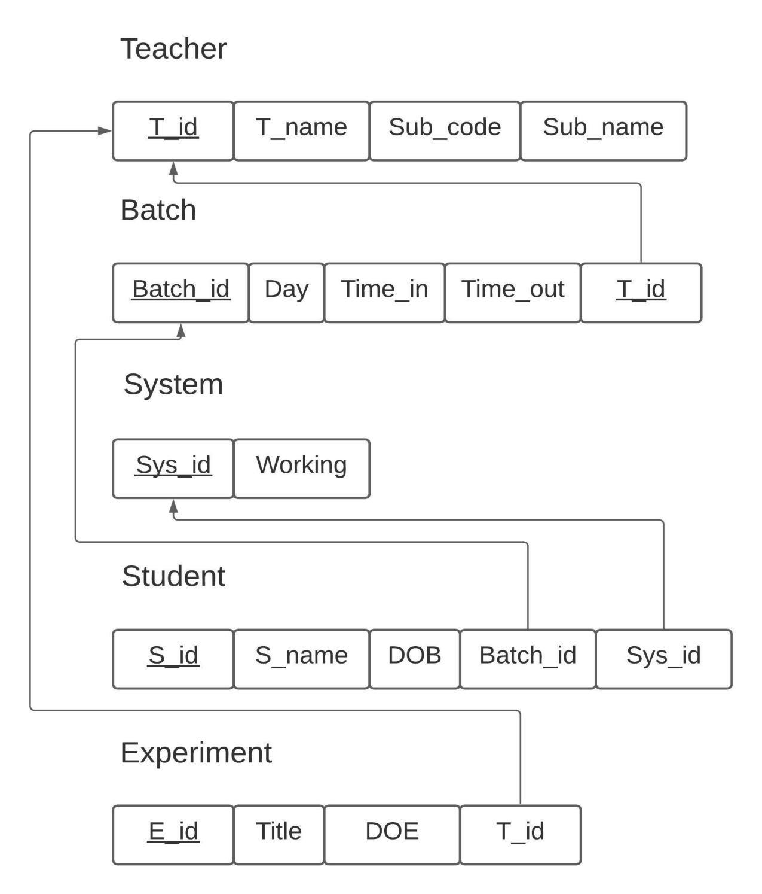

Figure 3.1: Relational schema

Description: In Fig 3.1 and fig 3.2 the schema diagram of Computer-Laboratory Management System where each table has attributes and some attributes are underlined, it is called primary key and this primary key is referred in another table as foreign key and this representation is done with the schema diagram as shown in figure. For example, teacher table the entity t_id is primary key and it is used as foreign key in tables batch and experiment as t_id. 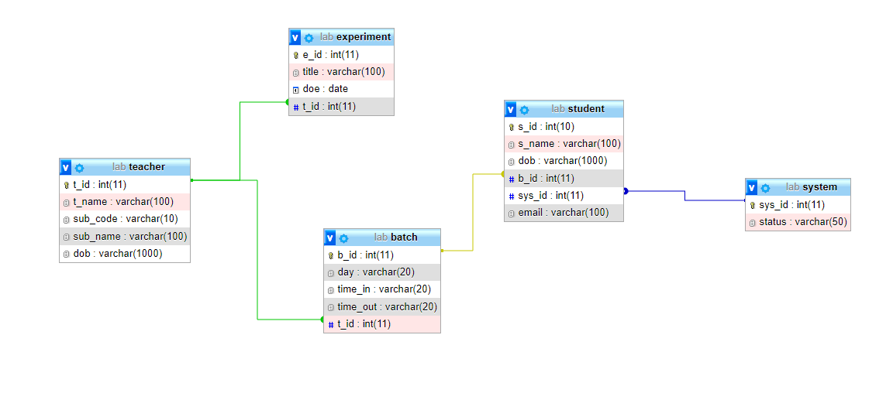
Figure 3.2: Relational schema pictorial

  - ER Diagram

An entity–relationship model is usually the result of systematic analysis to define and describe what is important to processes in an area of a business. An E-R model does not define the business processes; it only presents a business data schema in graphical form. It is usually drawn in a graphical form as boxes (entities) that are connected by lines (relationships) which express the associations and dependencies between entities. An ER model can also be expressed in a verbal form, for example: one building may be divided into zero or more apartments, but one apartment can only be located in one building. Entities may be characterized not only by relationships, but also by additional properties (attributes), which include identifiers called "primary keys". Diagrams created to represent attributes as well as entities and relationships may be called entity-attribute- relationship diagrams, rather than entity-relationship models.
An ER model is typically implemented as a database. In a simple relational database implementation, each row of a table represents one instance of an entity type, and each field in a table represents an attribute type. In a relational database a relationship between entities is implemented by storing the primary key of one entity as a pointer or "foreign key" in the table of another entity. There is a tradition for ER/data models to be built at two or three levels of abstraction. Note that the conceptual-logical-physical hierarchy below is used in other kinds of specification, and is different from the three- schema approach to software engineering.
The four main cardinal relationships are:
- One-to-one (1:1) - For example, each customer in a database is associated with one mailing address.
- One-to-many (1: N) - For example, a single customer might place an order for multiple products. The customer is associated with multiple entities, but all those entities have a single connection back to the same customer.
- Many-to-one (N: 1) – For example, many employees will have only one manager above them but one manager can have many employees below him.
- Many-to-many (M: N)- For example, at a company where all call center agents work with multiple customers, each agent is associated with multiple customers, and multiple customers might also be associated with multiple agents.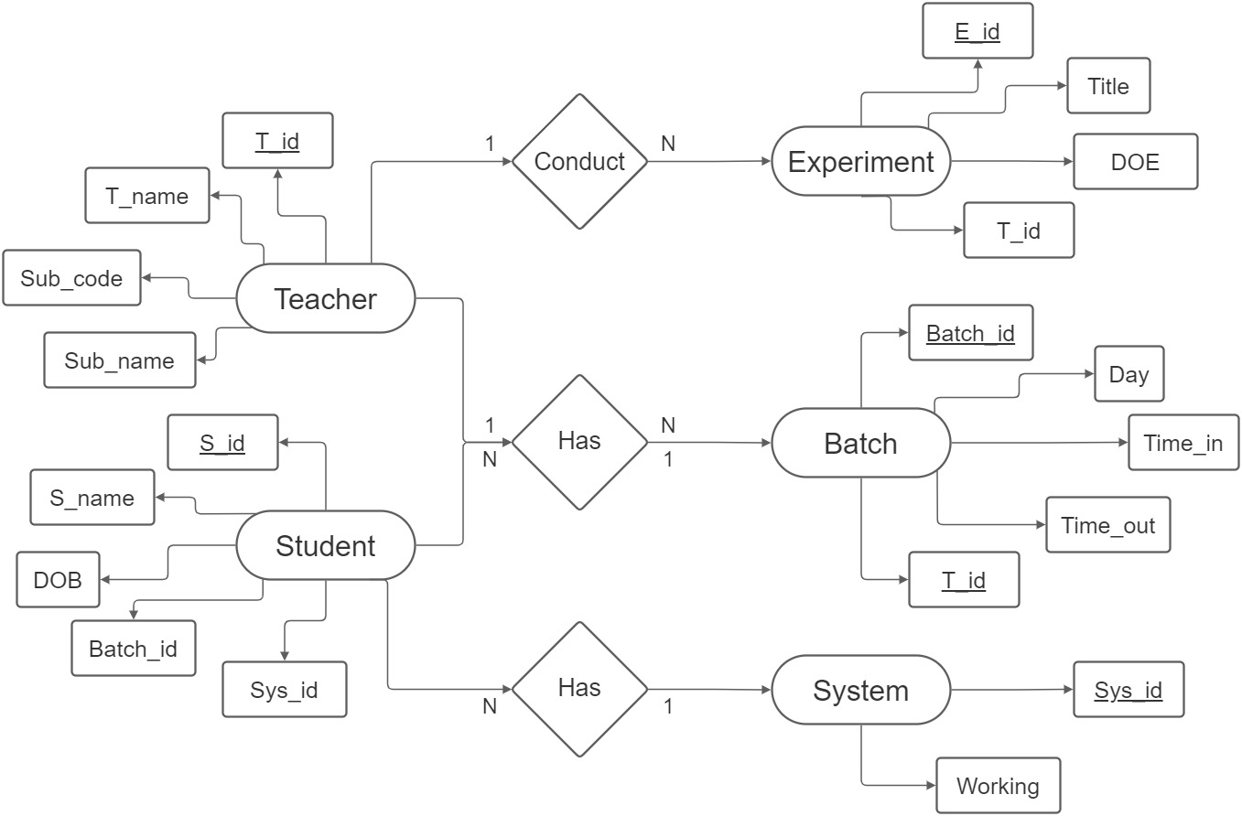
Figure 3.3: ER-Diagram

Description:. ER Diagram created for the project.

CHAPTER 4

System Implementation

4.1 Implementation
Implementation is the stage in the project where the theoretical design is turned into a working system and is giving confidence on the new system for the users that it will work efficiently and effectively. It involves careful planning, investigation of the current system and its constraints on implementation, design of methods to achieve the changeover, an evaluation of change over methods. Implementation is the most important phase. The most critical stage in achieving a successful new system is giving the users confidence that the new system will work and be effective. Any system developed should be secured and protected against possible hazards. Security measures are provided to prevent unauthorized access of the database at various levels. Password protection and simple procedures to prevent unauthorized access are provided to the users.
The goal of this application is to manage the students, batches and its various functions of the computer laboratory.

4.2 Connection of Data Base
Description: SQLAlchemy data base is connected with server which is made by using Flask framework as shown in fig 4.1.

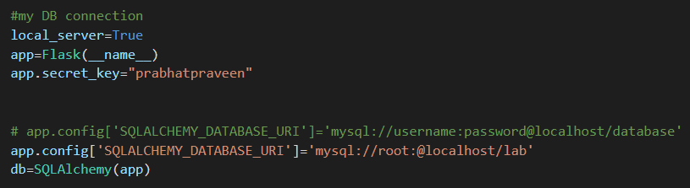
Figure 4.1: Connection of Data Base

4.3 Creation of table
- Teacher
Description:. Creation of teacher table and table structure created for the project.
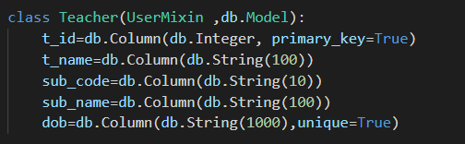
Figure 4.2: Teacher table

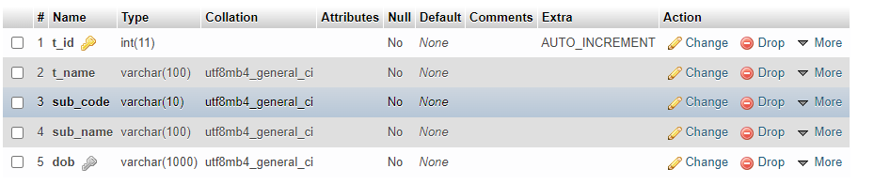
Figure 4.4: Teacher table structure

- Batch
Description:. Creation of batch table and table structure created for the project.

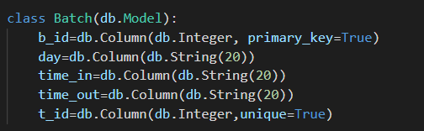
Figure 4.3: Batch table

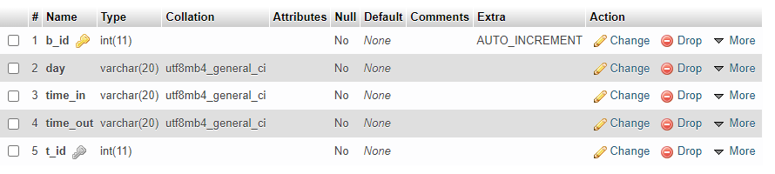
Figure 4.4: Batch table structure

- System
Description:. Creation of system table and table structure created for the project.

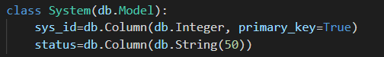
Figure 4.5: System table

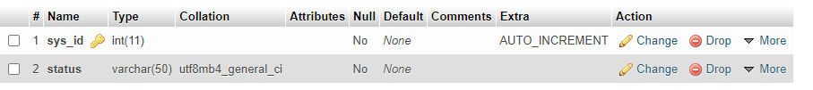
Figure 4.6: System table structure

- Student
Description:. Creation of student table and table structure created for the project.

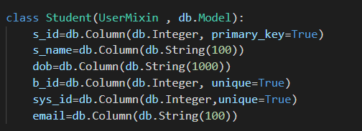
Figure 4.7: Student table

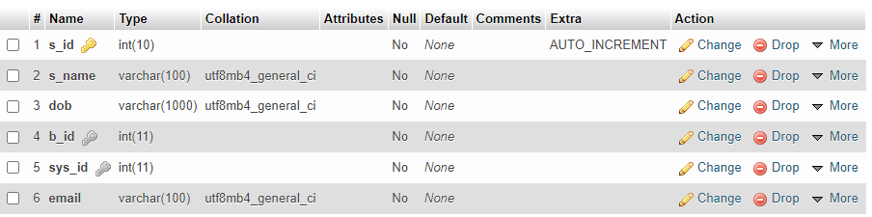
Figure 4.8: Student table structure

- Experiment
Description:. Creation of experiment table and table structure created for the project.

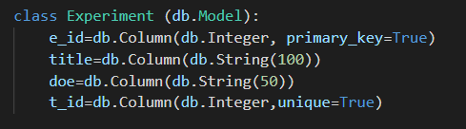
Figure 4.9: Experiment table

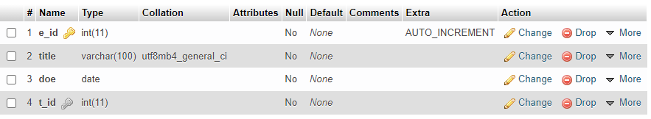
Figure 4.10: Experiment table structure

4.4 Lab Data Base
Description:. Shown a Lab database structure which has been created of the project.

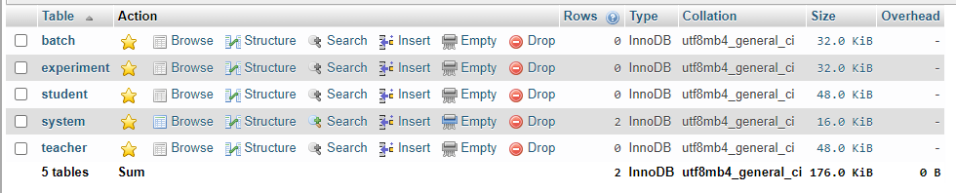
Figure 4.11: Lab Data Base

4.5 Insertion of values

- Teacher
Description:. Values inserted in teacher table.
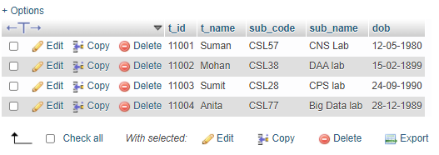
Figure 4.12: Teacher table data

- Batch
Description: Values inserted in system table.
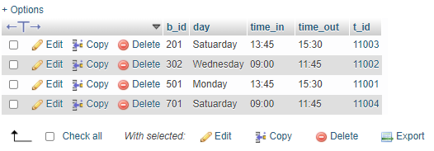
Figure 4.13: Batch table data

- System
Description:. Values inserted in system table.

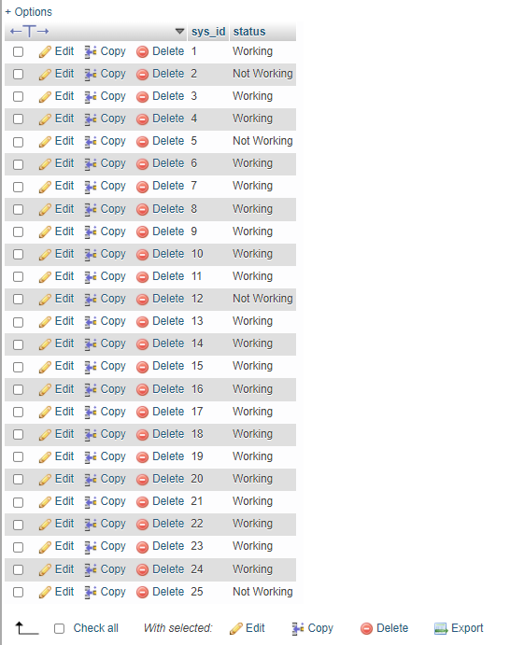
Figure 4.14: System table data

4.6 Trigger
A triggering event is a tangible or intangible barrier or occurrence which, once breached or met, causes another event to occur. Triggering events include job loss, retirement, or death, and are typical for many types of contracts. These triggers help to prevent, or ensure, that in the case of a catastrophic change, the terms of an original contract may also change.
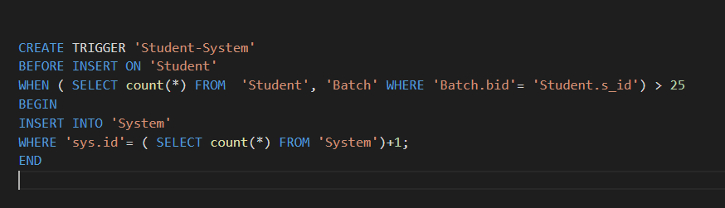
Figure 4.15: Trigger

Description: It shows the trigger code used in this project.

CHAPTER 5
Snapshots

  - Home page
Description: It shows a beautiful home page form where we can login in various in Admin, student and teacher user page.

Figure 5.1: Home page #1


Figure 5.2: Home page #2

  - Login Page

Description: It shows login page which gives authentication to enter into the work page. It navigates to the home page if username and password are correct, else it will give out error.
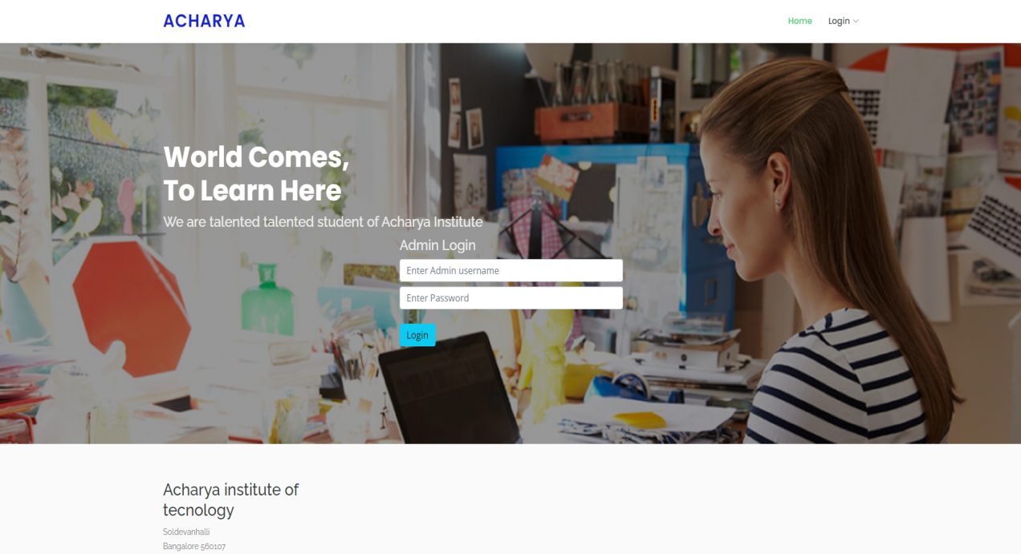
Figure 5.3: Login page
  - Home Page
Description: It shows Home Page of Admin which allows admin to navigate between all the functions and tables available in the system.
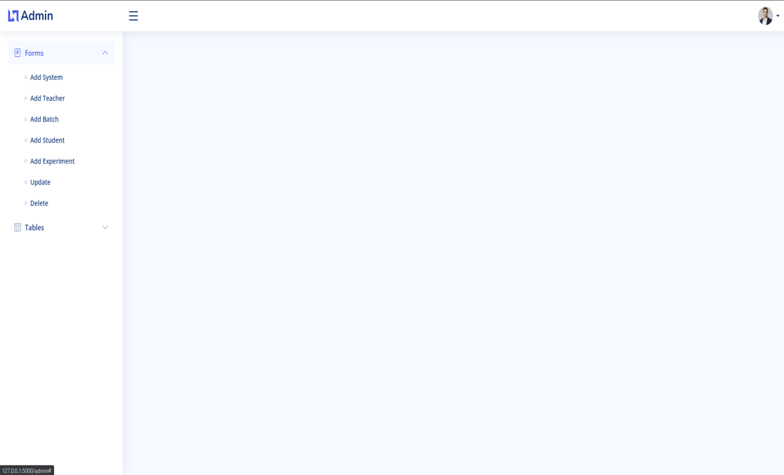

Figure 5.4: Admin home page

  - Add System

Description: It shows columns that are needed to be filled for entry onto the system for the System table.

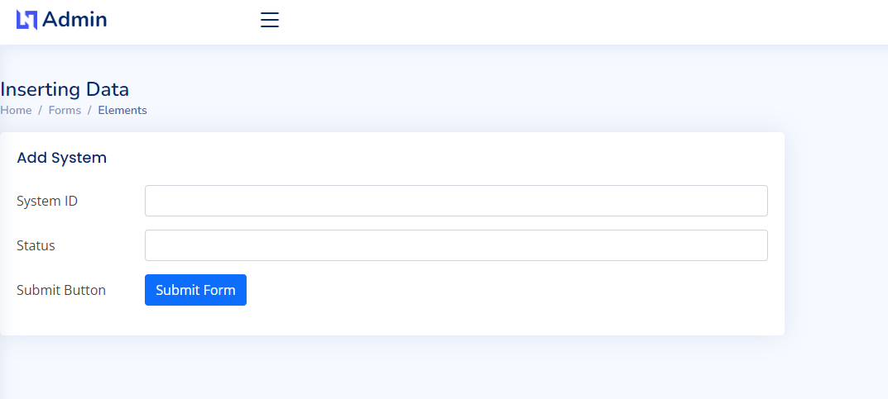

Figure 5.5: Add system page

  - Add Teacher
Description: It shows columns that are needed to be filled for entry onto the system for the teacher table.

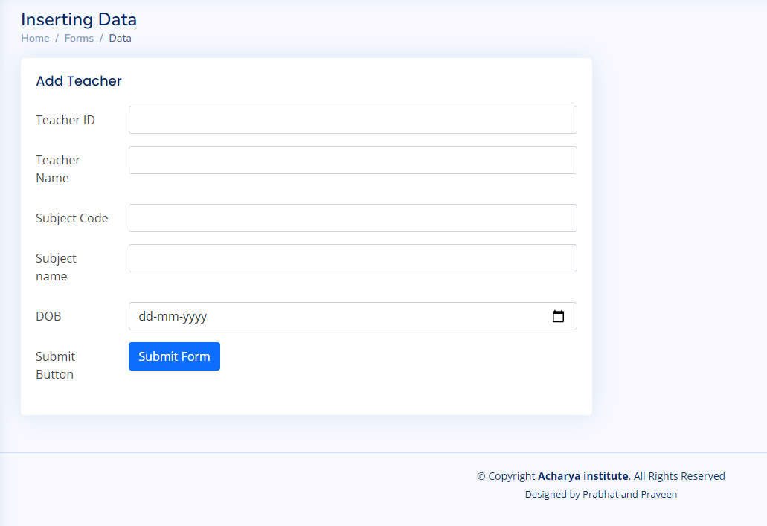
Figure 5.6: Add Teacher page

  - Add Batch
Description: It shows columns that are needed to be filled for entry onto the system for the Batch table.
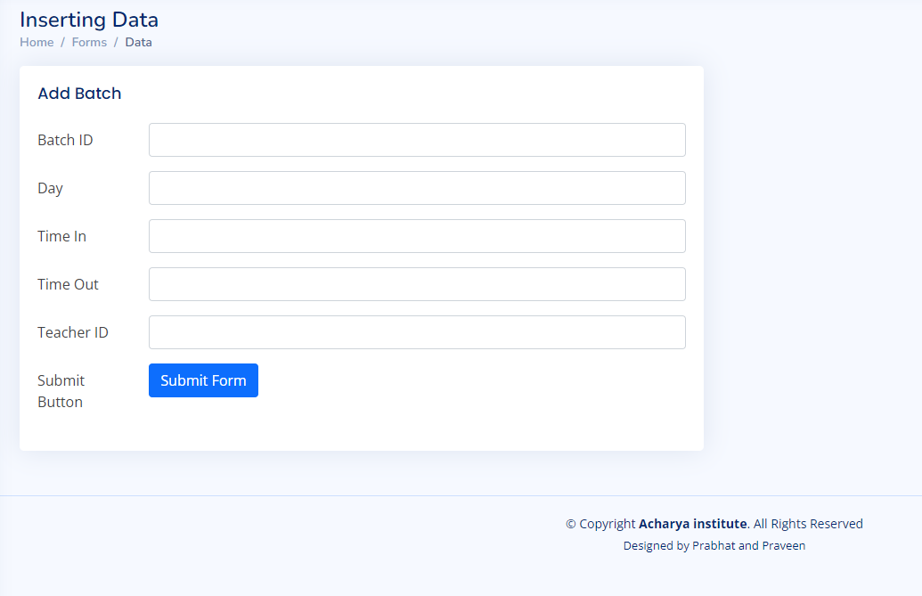

Figure 5.7: Add Batch page
  - Add Student
Description: It shows columns that are needed to be filled for entry onto the system for the Student table.
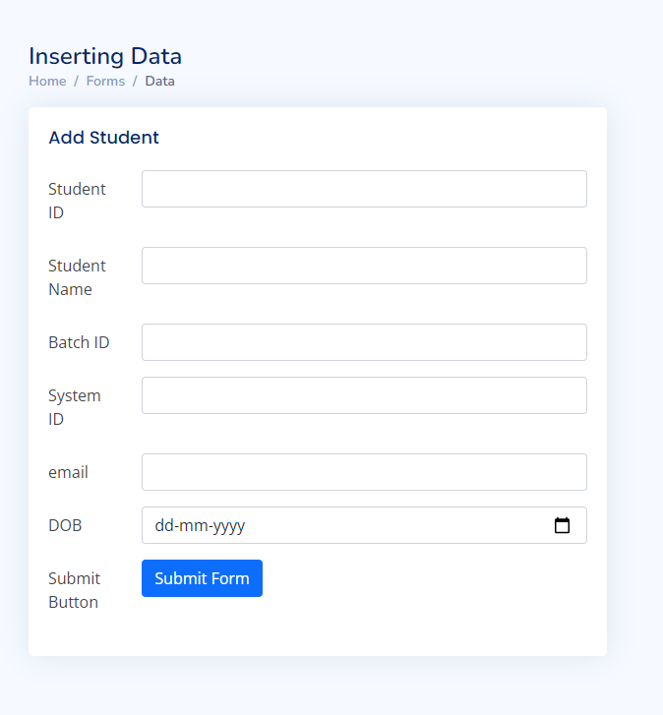
Figure 5.8: Add Student page

  - Add Experiment
Description: It shows columns that are needed to be filled for entry onto the system for the Experiment table
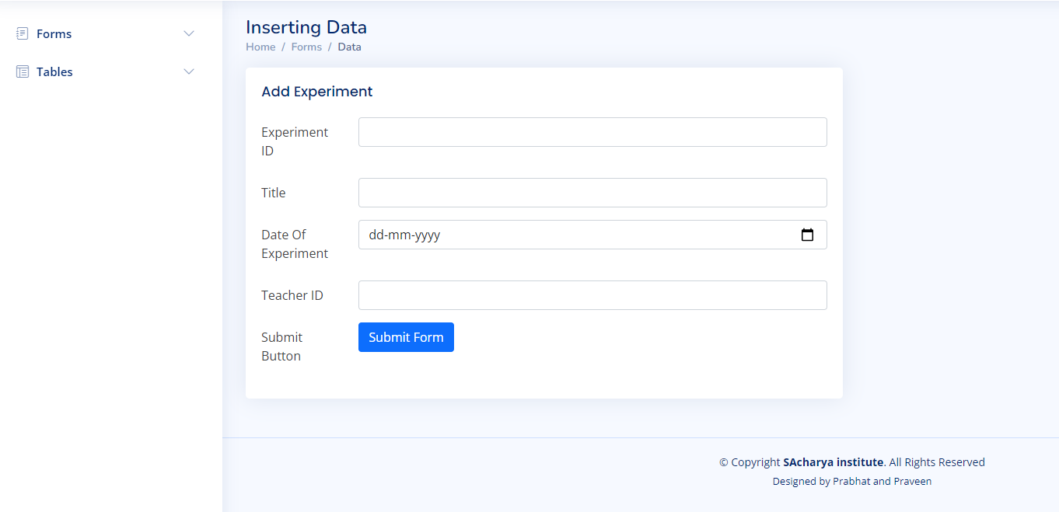
Figure 5.9: Add Experiment page

  - Editing and Deleting
Description: Here in this figure we have can update and delete data. The existing data is already present and ready to be modified.

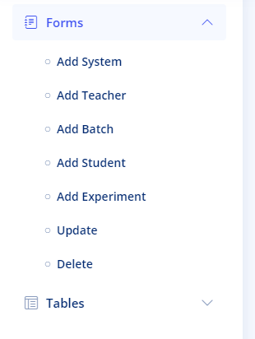

Figure 5.10: Update and delete page

  - Data Tables
Description: Here in this figure we have shown how the different tables information is represented in table form .
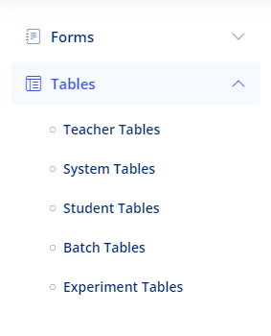
Figure 5.11: data table page

CHATPER 6

Conclusion

Computer-Laboratory Management System project, developed using PYTHON and MySQL is based Data Base SQLAlchemy on the requirement specification of the user and the analysis of the existing system, with flexibility for future enhancement. Computer-Laboratory Management System software is designed for people who want to manage various particulars can be known by recording them in the database. The numbers of students, teachers, batches and system are going to increase day-by-day. And hence there is a lot of strain on the person who are managing the Laboratory to know about number of students in the batch and System in the Laboratory. Identification of the drawbacks of the existing system leads to the designing of computerized system that will be compatible to the existing system with the system which is more user friendly and more GUI oriented.

Bibliography

- https://flask-admin.readthedocs.io/en/latest
- https://flask.palletsprojects.com/en/2.0.x/
- https://wtforms.readthedocs.io/en/3.0.x/
- https://www.w3schools.com/

- https://hackersandslackers.com/flask-login-user-authentication/
- http://stackoverflow.com
- https://www.tutorialspoint.com
- https://bootstrapmade.com
- https://youtube.com/

